**Experiment No.: 1 Date:28/10/2022**

**Aim:**

Demonstrate a registration form using HTML.

**CO1:**

Explore markup languages features and create interactive web pages using them.

**Procedure:**

<html>

<head>

<title>

Application Form

</title>

</head>

<body background="https://c0.wallpaperflare.com/preview/391/321/157/botany-dark-green-plants-fern-foliage.jpg">

<form action="/login.php">

<h1> <center><font color="7F7F7F">Student Registration Form </font> </center><h1>

<table style="color:white"width="30%"height="60" align="center" border="7" bordercolor="7F7F7F" cellpadding="10">

<tr>

<th>First name&nbsp; <input type="text" name="text"></th></tr>

<tr><th>Last name&nbsp; <input type="text" name="text"></th></tr>

<tr><th>Address&nbsp;<textarea rows="1" cols="20"></textarea></th></tr>

<tr><th>Previous Institution&nbsp;<input typr="text" name="college"></th></tr>

<tr><th>Gender&nbsp;&nbsp;

<input type="radio" name="gender" value="male"> Male<br>

&nbsp;

&nbsp;

&nbsp;

&nbsp;

&nbsp;

&nbsp;

&nbsp;

&nbsp;

&nbsp;

&nbsp;

<input type="radio" name="gender" value="female"> Female</th></tr>

<tr><th>Date of Birth&nbsp;&nbsp;&nbsp;

<input type="date" name="date"></th></tr>

<tr><th> E-maili&nbsp; &nbsp;&nbsp;<input type="email" name="email"></th></tr>

<tr><th> Mobile number<input type="tel" name="number"></th></tr>

<tr><th>District&nbsp;&nbsp;&nbsp;&nbsp;&nbsp;&nbsp;&nbsp;

<select name="District">

<option selected>Kottayam</option>

<option selected>Idukki</option>

<option selected>Kollam</option>

<option selected>Kannur</option>

<option selected>Thrissur</option>

<option selected>Select district</option>

</th></tr>

<tr><th> <input type="submit" value="SUBMIT">

<input type="reset" value="RESET"></th></tr>

</select>

</table>

</form>

</body>

</html>

Output Screenshot:

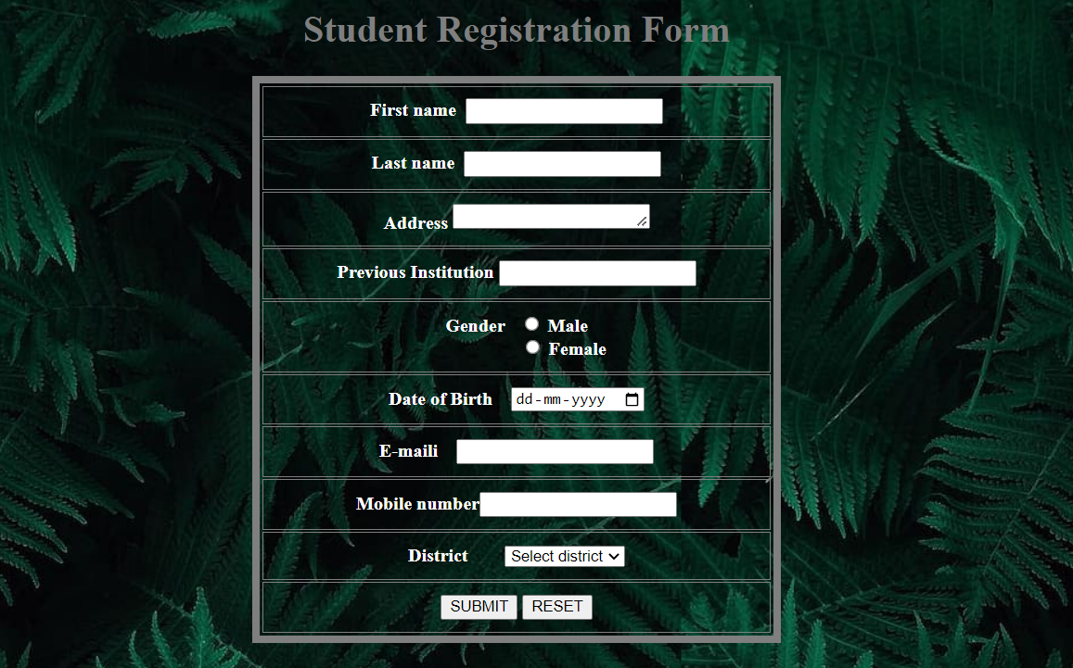

**Result**

The program was executed and the result was successfully obtained. Thus CO1 was obtained.

**Experiment No.: 2 Date:28/10/2022**

**Aim:**

Create a HTML file to link to different HTML page which contains images, tables, and also link within a page.

**CO1:**

Explore markup languages features and create interactive web pages using them.

**Procedure:**

***(Main page):***

<html>

<head>

<title>WELCOME</title>

</head> <body <font color="lime" background="https://c4.wallpaperflare.com/wallpaper/819/896/34/car-honda-nsx-nissan-gtr-r34-wallpaper-preview.jpg">

<center>

<font color="white"><h1>WELCOME TO THE WORLD OF CARS</h1>

<h2>

<b>HYRUZ GROUP Website</b>

</h2>

</center>

<h2>

Cars <a href="cars.html"> ABOUT CAR</a>

<br><br>

<br><br>

</h2><h2>

<a href="GALLERY.html">CAR GALLERY</a>

<ul TYPE="square">

<li>nissan</li>

<li>toyota</li>

<li>honda</li>

<li>mistibushi</li>

</ul>

</h2>

<h2>

jdm spec

<ol>

<li>supra mkv4</li>

<li>gtr r 34</li>

<li> honda civic</li>

<li>mazda rx7</li>

</ol>

</font></h2>

</body>

</html>

***(Link pages):***

html>

<head>

<title>

automobiles

</title>

</head>

<body background="https://c4.wallpaperflare.com/wallpaper/985/116/48/forza-horizon-3-car-2k-nissan-skyline-gt-r-r34-wallpaper-preview.jpg" width="1000" height="600">

<font color="white"><h1>NISSAN GTR R-34</h1></font>

<font color="white"><p>The Nissan GT-R is a high-performance sports car and grand tourer produced by Nissan, unveiled in 2007.[3][4][5] It is the successor to the Skyline GT-R, a high performance variant of the Nissan Skyline. Although this car was the sixth-generation model to bear the GT-R name, the model is no longer part of the Nissan Skyline model line up since that name is now reserved for Nissan's luxury-sport vehicles. The GT-R is built on the exclusively-developed Nissan PM platform, which is an enhanced evolution of the Nissan FM platform used in the separate Nissan Skyline luxury car and the Nissan Z sports car. The GT-R abbreviation stands for Gran Turismo–Racing, obtained from the Skyline GT-R</p></font>

<img src="https://images.hdqwalls.com/wallpapers/red-nissan-gtr-r34-02.jpg" width="1700" height="800"></img>

</body>

</html>

***(Link pages2):***

<html>

<head>

<title>

</title>

</head>

<body background="https://wallpaperaccess.com/full/11207.jpg">

<h1><center> Hyruz Group Car Garage</center></h1>

<font color="white"> <marquee> <h2>It is a official website of hyruz group.This car are owned by HZ.For paid promotion contact as!!</h2> </marquee></font>

</body>

</html>

Output Screenshot:

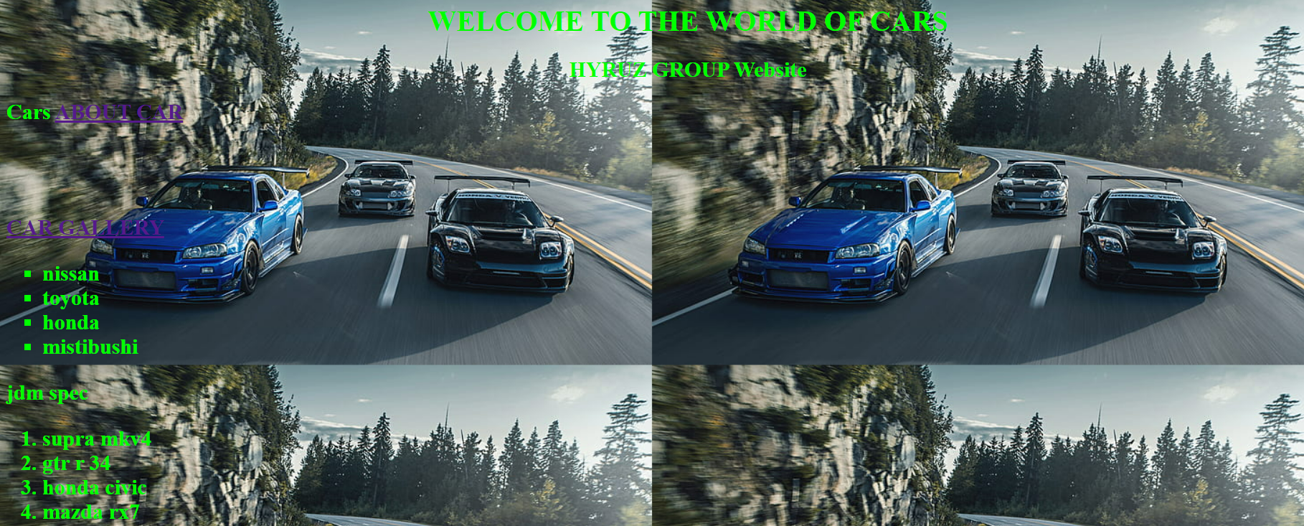

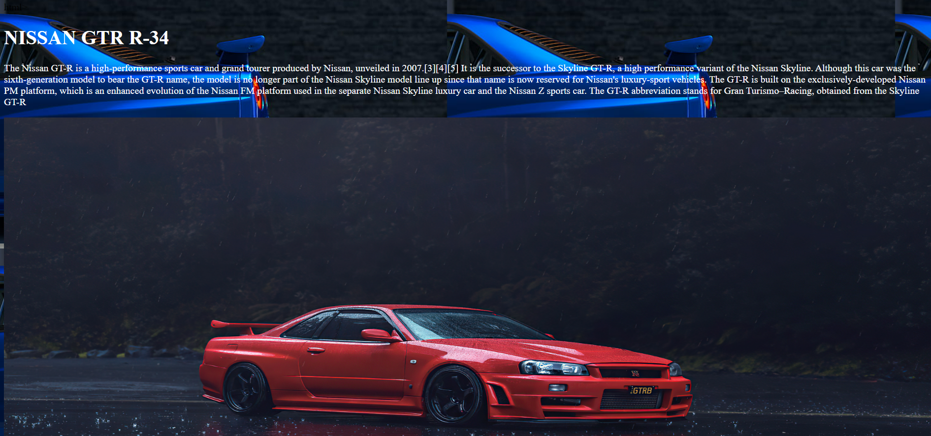

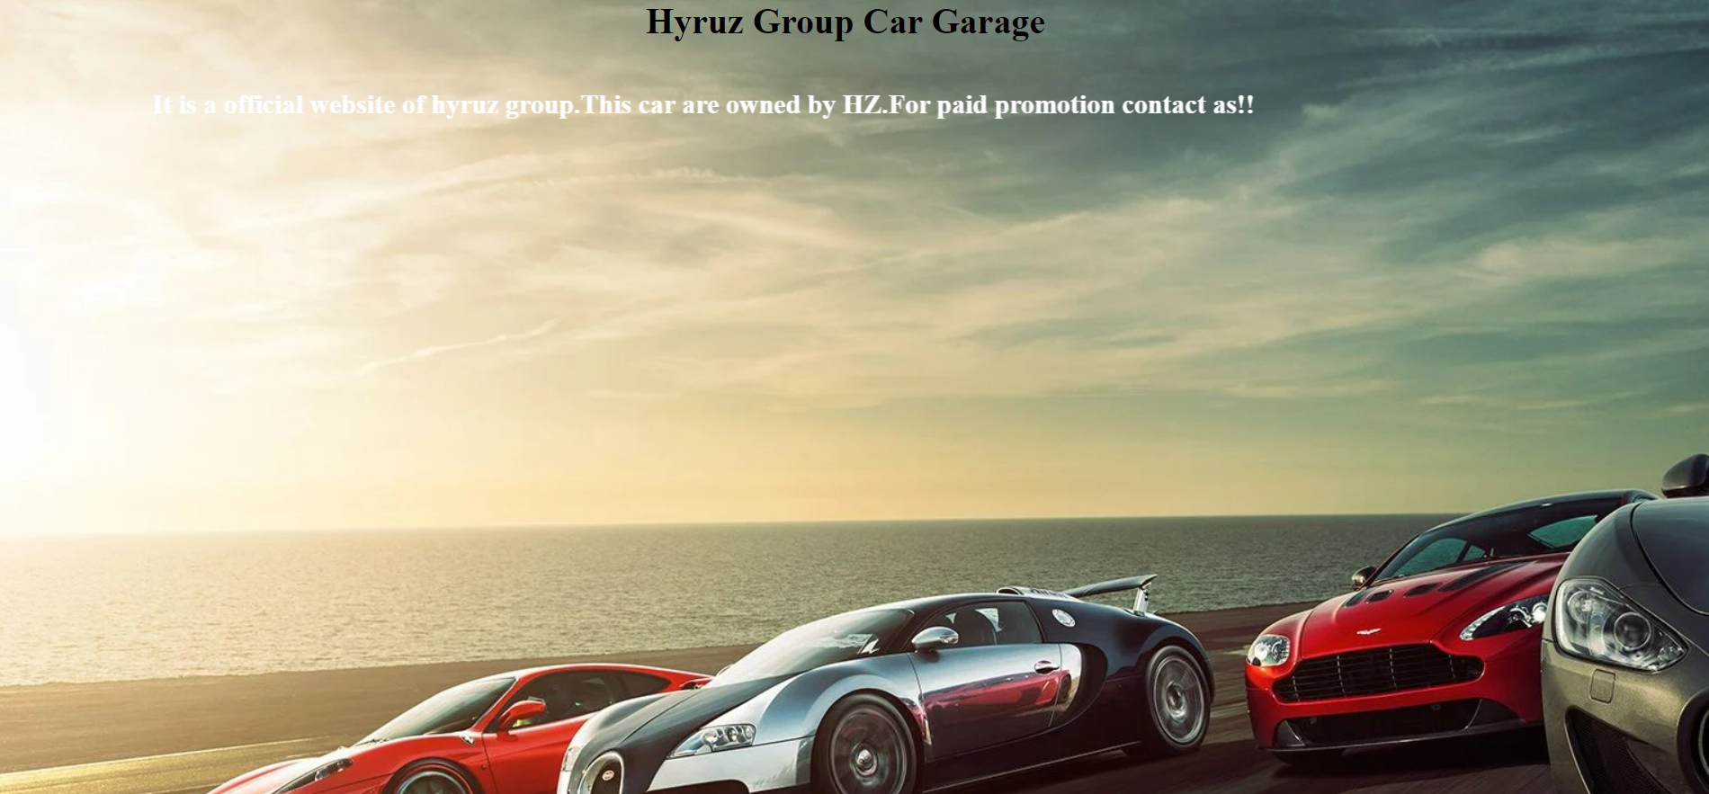

**Result**

The program was executed and the result was successfully obtained. Thus CO1 was obtained.